Smart City Traffic Optimization System Project Documentation
Name-Rishabh Yadav
University-UPES
Enrollment Number-500122500

1. What Is This Project?
The Smart City Traffic Optimisation System is an AI-powered web platform that monitors, analyses, and optimises urban traffic flow across a simulated 25-intersection city grid. It provides a real-time dashboard for traffic operators to visualise congestion, manage incidents, prioritise emergency vehicles, and let an AI engine automatically adjust traffic signal timings — all from a single interface.
Key capabilities at a glance:
Feature | Description
Real-time monitoring | Live traffic volume, speed, congestion level, and queue length per intersection
AI signal optimisation | Rule-based engine auto-adjusts green/red signal durations based on congestion, weather, zone, and emergencies
Emergency vehicle priority | Dispatches and tracks emergency vehicles; automatically extends green signals on their route
Analytics dashboard | Hourly patterns, congestion distribution, weather impact, heatmaps, and historical trends
Incident management | Log, track, and resolve traffic incidents (accidents, road works, special events)
Notification system | Real-time alerts for AI actions, emergencies, system health, and anomalies
LSTM/Transformer models | Deep learning models (PyTorch) for traffic volume prediction and optimal signal timing
Traffic simulation | 7-day synthetic traffic generator using METR-LA network topology

2. Why Was It Built?
Urban traffic congestion is one of the costliest problems facing modern cities — wasted fuel, increased emissions, delayed emergency response, and reduced quality of life.
This project was built as a Xebia internship project to demonstrate how AI and data-driven approaches can:
- Reduce congestion by dynamically adjusting signal timings instead of using fixed schedules.
- Prioritise emergency vehicles by overriding signals to clear their path.
- Provide actionable insights to traffic operators through rich analytics.
- Simulate realistic scenarios (weather, incidents, rush hours) for testing optimisation strategies before real-world deployment.
It serves as both a functional prototype and a learning platform for smart city infrastructure.

3. How Does It Work?

3.1 Architecture Overview
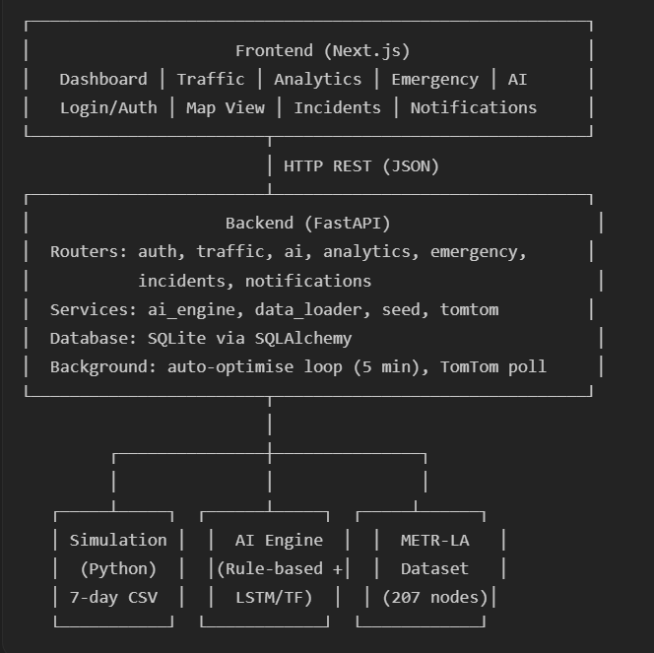

3.2 Data Pipeline
- Simulation → simulation.py generates a 7-day traffic dataset across 25 intersections (a 5×5 grid mapped to METR-LA topology). It produces ~16,800 records with 28+ columns including volume, speed, queue length, weather, incidents, emissions, and Level of Service.
- Data loading → On backend startup, data_loader.py ingests the simulation CSV and any METR-LA CSV into the SQLite database, tagged by source (simulation, metro).
- Live data (optional) → A background loop polls the TomTom Traffic Flow API every 15 minutes for real-time speed/congestion data at each intersection's coordinates.
- Seeding → seed.py populates the database with 25 signal configurations, 15 emergency vehicles, sample incidents, notifications, and demo users (admin + officer).

3.3 AI Optimisation Engine
The core engine (ai_engine.py) is a rule-based system designed for easy future replacement with ML models:
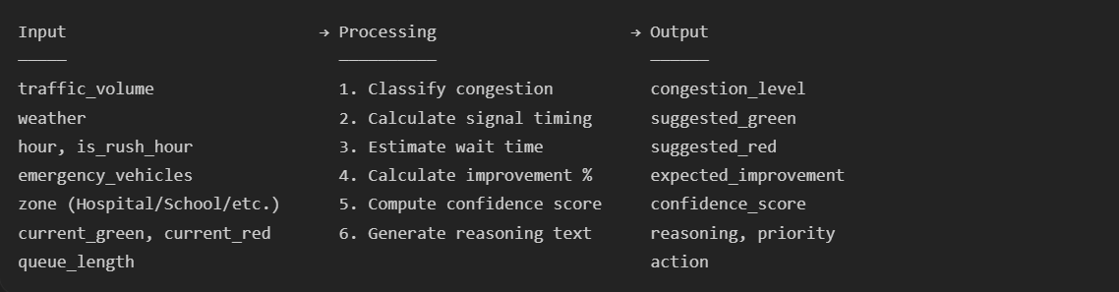
Key rules:
- Weather factors increase effective volume (Rain ×1.25, Snow ×1.45, Thunderstorm ×1.50).
- Zone weights boost priority (Hospital ×1.3, School ×1.2).
- Emergency vehicles add +15 seconds green per vehicle.
- Rush hour detection (7–10 AM, 4–8 PM) extends green by 10 seconds.
Auto-optimisation loop: Every 5 minutes, a background task scans all intersections. If congestion is High/Critical or an emergency vehicle is present, it auto-applies the AI recommendation and logs the action.

3.4 Deep Learning Models
The ai_engine/ directory contains two PyTorch models:
Model | Architecture | Purpose
TrafficLSTM | 2-layer LSTM → 5 prediction heads | Predicts volume, congestion class, speed, optimal green time, and wait time from sequential traffic data
TrafficTransformer | 2-layer Transformer Encoder → 5 heads | Alternative with better long-range temporal dependency capture
Both models take input shape (batch, seq_len, 12 features) and output multi-task predictions. Training pipeline is in train.py, inference in predictor.py.

3.5 Backend API
All API routes require JWT authentication (except login/register). Key endpoint groups:
Router | Prefix | Key Endpoints
Auth | /api/auth | POST /login, POST /register, GET /me, PUT /profile, PUT /change-password
Traffic | /api/traffic | GET /current, GET /historical, GET /heatmap, GET /intersections
AI | /api/ai | POST /optimize, POST /auto-optimize-all, GET /action-log, POST /revert/{id}, GET /predictions
Analytics | /api/analytics | Summary stats, hourly/zone breakdowns, weather impact
Emergency | /api/emergency | GET /vehicles, POST /alert, PUT /priority/{id}, GET /dashboard
Incidents | /api/incidents | CRUD for traffic incidents
Notifications | /api/notifications | List, mark read, bulk operations

3.6 Frontend Dashboard
Built with Next.js + TypeScript + Recharts, the dashboard has 7 main pages:
Page | What It Shows
Dashboard Overview | KPI cards (volume, speed, wait time), hourly bar chart, congestion pie chart, interactive map, recent alerts
Traffic Monitoring | Current intersection status, live congestion data, signal states
Analytics | Historical trends, heatmaps, zone-wise and weather-impact analysis
AI Optimization | Run manual optimisations, view action log, revert changes, auto-optimise all
Emergency | Vehicle fleet status, dispatch alerts, priority signal activation
Incidents | Report/track accidents, road works, and special events
Notifications | All system alerts with severity filtering

3.7 Authentication & Roles
Role | Access
admin | Full access — manage users, run bulk AI optimisations, view all logs
officer | Operational access — monitor traffic, dispatch emergencies, manage incidents
analyst | Read-only analytics and traffic data
Demo credentials:
- Admin: admin@smartcity.com / Admin@123
- Officer: officer@smartcity.com / Officer@123

4. How to Use It

4.1 Prerequisites
- Node.js v18+
- Python 3.10+
- Docker (optional, for containerised deployment)

4.2 Quick Start
Backend:
bash

cd backend
python -m venv venv
venv\Scripts\activate # Windows
pip install -r requirements.txt
uvicorn main:app --reload --port 8000
→ API docs at http://localhost:8000/docs
Frontend:
bash

cd frontend
npm install
npm run dev
→ Dashboard at http://localhost:3000
Docker (one command):
bash

docker-compose up --build

4.3 Running the Traffic Simulation
bash

python simulation.py
Generates traffic_simulation.csv — a 7-day dataset with ~16,800 rows across 25 intersections.

4.4 Training the AI Model
bash

cd ai_engine
python train.py
Trains the LSTM/Transformer on the simulation data and saves model weights.

4.5 Environment Variables
Create a backend/.env file:
env

SECRET_KEY=your-secret-key
DATABASE_URL=sqlite:///./smart_city_traffic.db
CORS_ORIGINS=http://localhost:3000
TOMTOM_API_KEY=your_tomtom_api_key_here # optional, for live traffic

5. How to Maintain It

5.1 Database
- Engine: SQLite (file: backend/smart_city_traffic.db). Zero configuration, but switch to PostgreSQL for production by changing DATABASE_URL.
- Schema: Auto-created on startup via SQLAlchemy's create_tables(). Models live in backend/app/models/.
- Seeding: On every startup, seed.py checks and populates default data (signals, vehicles, users) if empty.

5.2 Key Files to Know
File | Purpose
backend/main.py | App entry point, startup lifecycle, background loops
backend/app/services/ai_engine.py | The AI optimisation logic — modify rules here
backend/app/services/data_loader.py | CSV ingestion pipeline
backend/app/services/seed.py | Default data seeding
simulation.py | Traffic data generator
traffic_network.py | City grid topology and METR-LA graph utilities
frontend/src/lib/api.ts | All frontend API calls
frontend/src/app/globals.css | Global styles and design system

5.3 Monitoring
- Health check: GET /health returns system status.
- AI health: GET /api/ai/health returns engine status, data availability, and model metrics.
- Auto-optimisation status: GET /api/ai/auto-status shows today's applied/skipped actions and average improvement.
- Logs: Backend logs to stdout with timestamps via Python's logging module.

6. How to Extend It

6.1 Replace the Rule-Based Engine with ML
The AI engine uses a Strategy Pattern — swap the rule-based logic with the trained LSTM/Transformer:
- Train a model: python ai_engine/train.py
- In backend/app/services/ai_engine.py, replace the optimize() method to load the PyTorch model and run inference instead of rule-based logic.
- The TrafficInput → TrafficRecommendation interface stays the same.

6.2 Add a New Intersection Zone
- Update ZONE_MAP in traffic_network.py
- Add zone-specific traffic profiles in simulation.py (get_base_volume, get_vehicle_distribution, get_traffic_multiplier)
- Add zone weight in ai_engine.py → ZONE_WEIGHTS
- Update seed.py to include signals for new intersections

6.3 Integrate Real Traffic Data
- TomTom API: Already integrated — set TOMTOM_API_KEY in .env. The background loop polls every 15 minutes.
- Other APIs: Add a new service in backend/app/services/, create a background loop in main.py, and write data to the TrafficData model with a new source tag.

6.4 Add a New Dashboard Page
- Create a new directory under frontend/src/app/dashboard/<page-name>/
- Add a page.tsx file with your component
- Add a navigation link in frontend/src/app/dashboard/layout.tsx
- Create API endpoints if needed in backend/app/routers/

6.5 Add a New API Router
- Create a new file in backend/app/routers/
- Define a router = APIRouter(prefix="/api/<name>", tags=["<Name>"])
- Register it in backend/main.py with app.include_router(your_router.router)

6.6 Tableau Dashboard
The project includes a Tableau workbook (City Traffic Optimisation System Dashboard.twb) for advanced visual analytics. Connect it to the exported simulation CSV or directly to the SQLite database.

7. Project Structure Summary
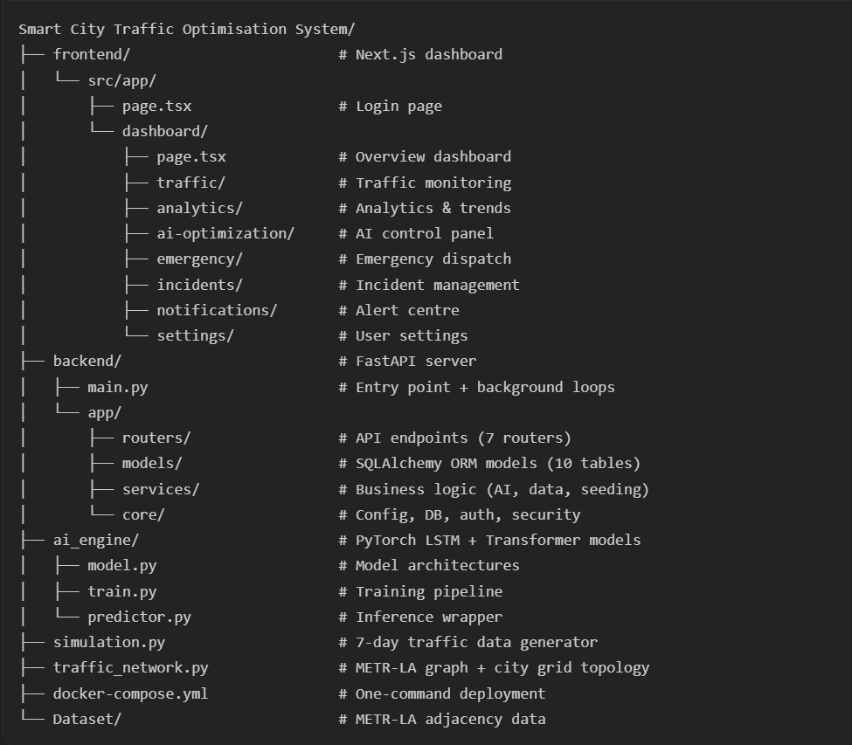
In short: This is a full-stack smart city prototype that simulates realistic traffic, uses AI to optimise signal timings in real-time, and presents everything through an interactive dashboard — ready to be extended with real sensors, ML models, and production databases.

8. System Diagrams

8.1 Use Case Diagram
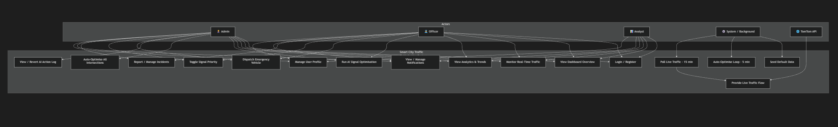

8.2 Data Flow Diagram — Level 0 (Context)
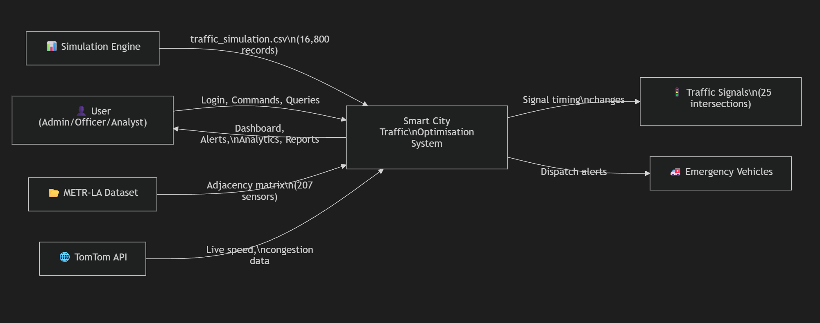

8.3 Data Flow Diagram — Level 1 (Detailed)
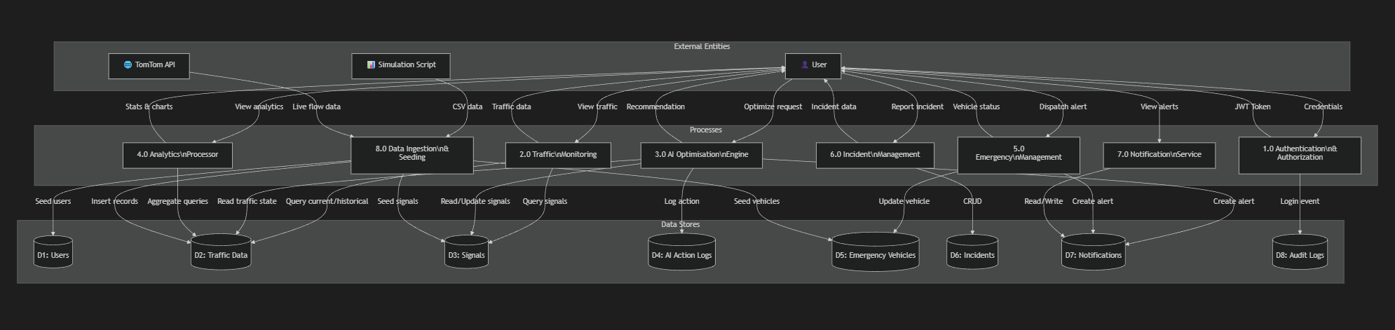

8.4 Entity Relationship Diagram
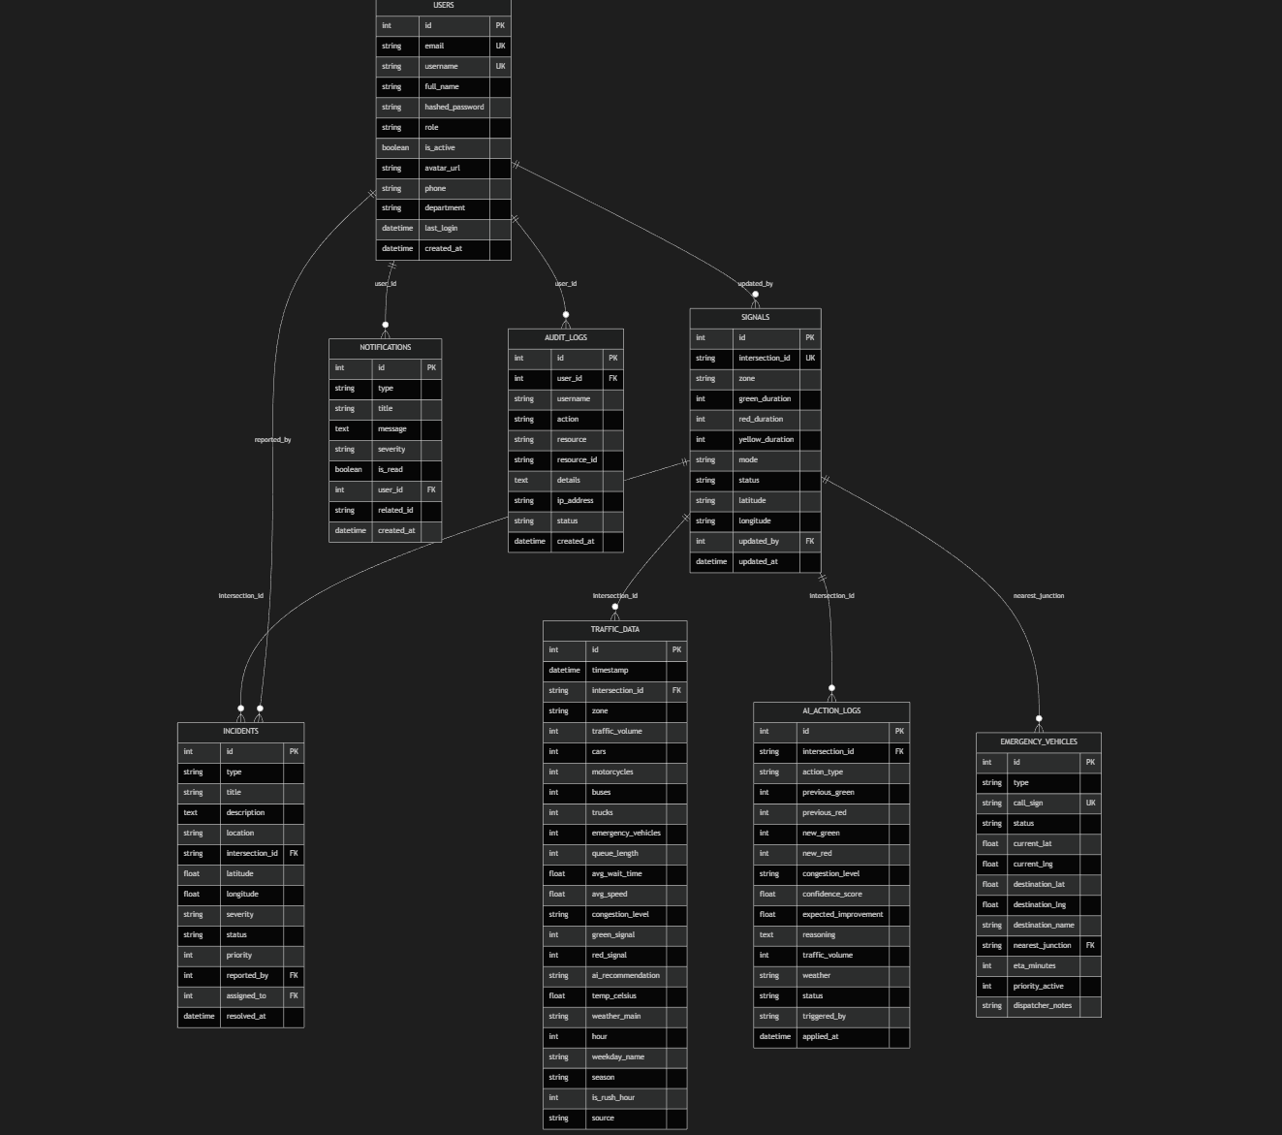

8.5 Sequence Diagram — User Login Flow
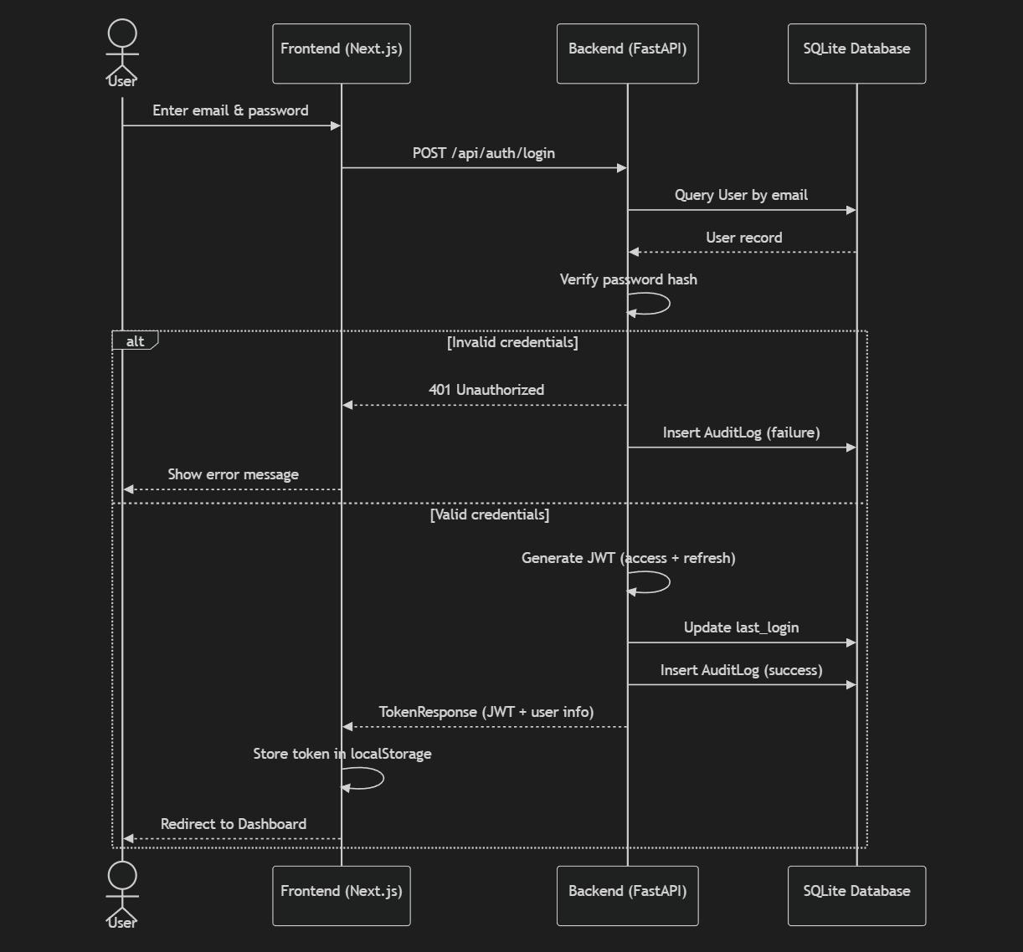

8.6 Sequence Diagram — AI Signal Optimisation
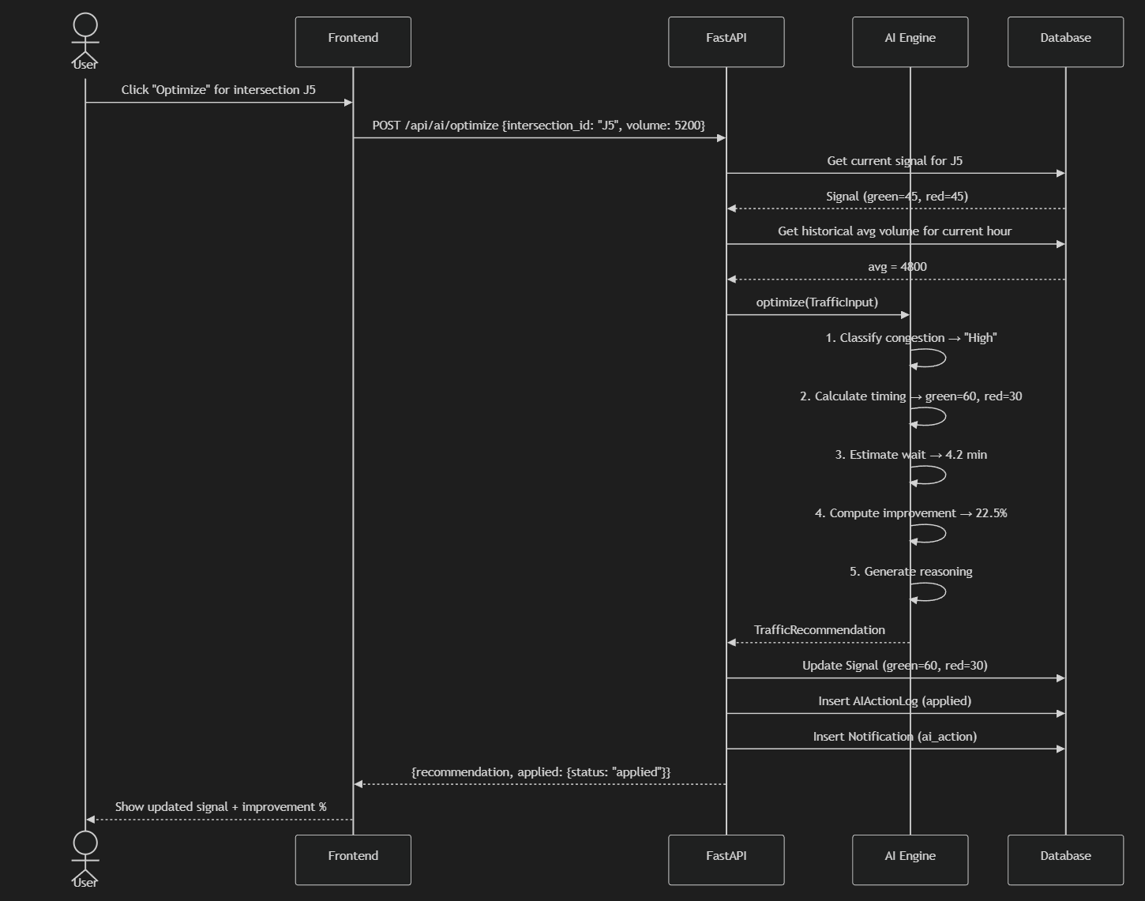

8.7 Sequence Diagram — Emergency Vehicle Dispatch
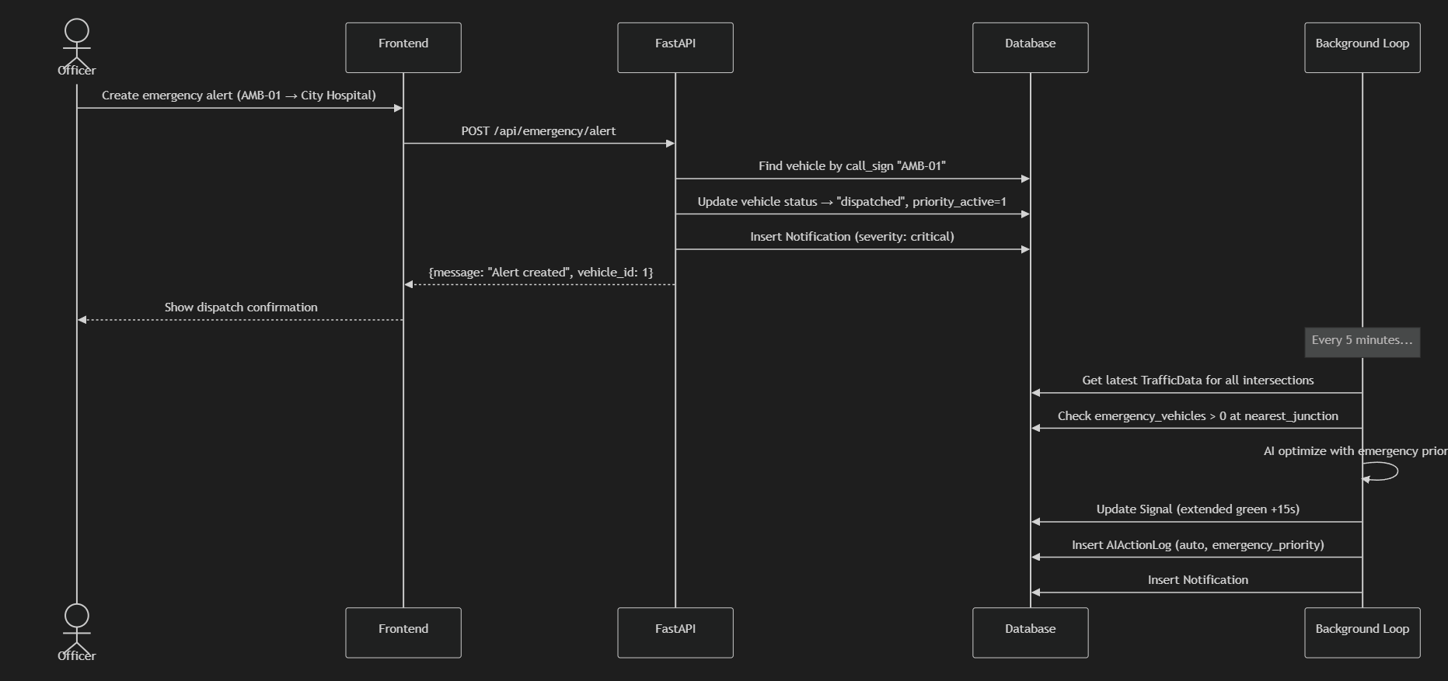

8.8 Component / Deployment Diagram
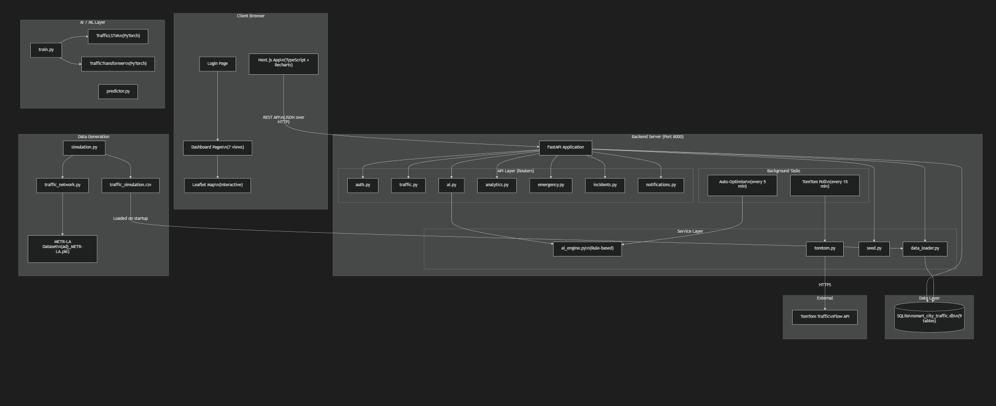

8.9 State Diagram — Emergency Vehicle Lifecycle
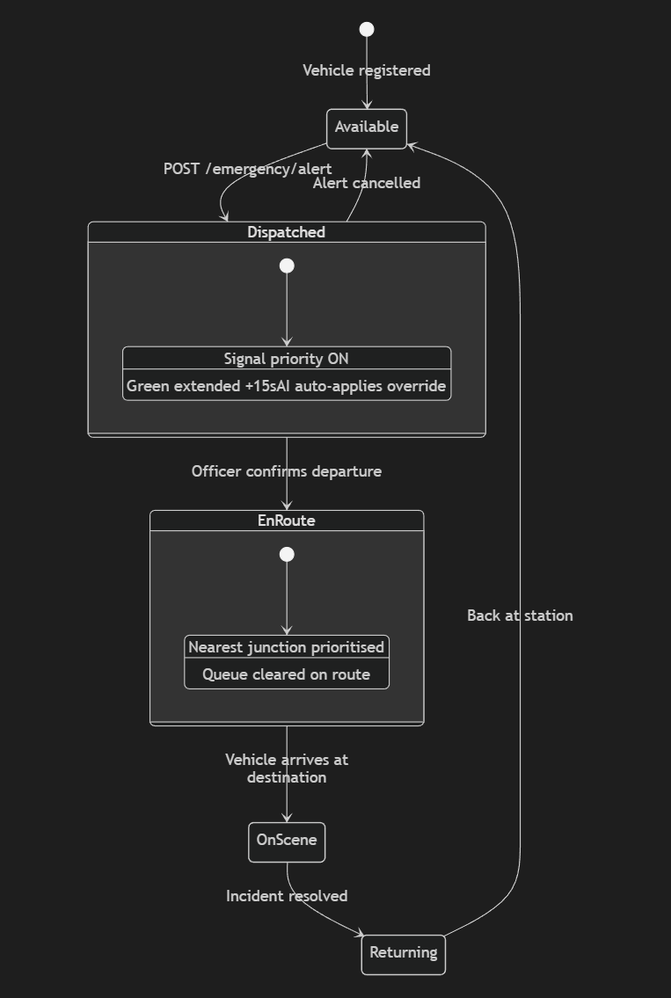

8.10 Activity Diagram — Auto-Optimisation Background Loop
